Langlopende taak: SpaceX

Website:

Deze website zal een fanbased pagina zijn voor mensen die geïnteresseerd zijn in de belangrijkste zaken over SpaceX.
Mijn website zal:
- Gebruiksvriendelijk zijn.
- Er professioneel uitzien.
- Gemakkelijk te vinden zijn door gebruik van sociale media.
- Makkelijk te navigeren zijn van pagina tot pagina.
- Engelstalig zijn zodat ik een breder publiek kan bereiken.

Pagina’s

Er zullen verschillende pagina’s zijn die gaan over:

- Doel:
- De prijzen van ruimtevaart verminderen
- Onderzoeken en koloniseren van Mars
- Commerciële ruimtevluchten
- Wereldwijde internetconnectiviteit
- Onderzoek op de maan
- Ruimtetoerisme
- Satellieten van klanten de ruimte insturen
- Wereldwijde samenwerking
- Geavanceerde raketindustrie opbouwen
- Wetenschappelijk onderzoek verrichten

- Missies:
- Voorbereidende vluchten van Dragon
- Commerciële bevoorrade missies
- Ruimtevluchten met en zonder crew
- StarLink-missies
- GPS-satellieten de ruimte insturen
- Falcon heavy test vluchten
- Toerisme op de maan
- Starship development
- Maanlandingen voor NASA
- Crew-2 missie
- GPS missie
- StarLink internetaanbiedingen
- Commercieel satellieten in de ruimte schieten
- Wetenschap in de ruimte
- Nationale en internationale veiligheid
- De Aarde in het oog houden

- Raketten:
-Belangrijkste missies

- Geschiedenis:
- Waar en wanneer ontstaan?
- Bedenker (Elon Musk)

- Concurrerende websites

Inhoud:

Doel:

SpaceX, or Space Exploration Technologies Corp., was founded by Elon Musk in 2002 with the overarching goal of advancing space exploration and making humanity a multi-planetary species. The primary purposes and objectives of SpaceX include:

1. **Reducing the Cost of Space Access:** One of SpaceX's primary goals is to significantly reduce the cost of launching payloads into space. By developing reusable rocket technology, such as the Falcon 9 and Starship, SpaceX aims to make space more accessible and economically viable for a wide range of applications, including scientific research, commercial ventures, and more.

2. **Exploring and Colonizing Mars:** Elon Musk's vision for SpaceX is to enable human colonization of Mars. He believes that this is critical for the long-term survival of humanity, as it would make humanity a multi-planetary species and reduce the risk of extinction events on Earth. The development of Starship is central to achieving this goal.

3. **Commercial Spaceflight:** SpaceX is a pioneer in the commercial spaceflight industry. It has worked with both government agencies, such as NASA, and commercial customers to launch satellites, cargo, and astronauts into space. The company's Crew Dragon spacecraft, for example, is used for crewed missions to the International Space Station (ISS) under NASA's Commercial Crew Program.

4. **Global Internet Connectivity:** SpaceX is deploying the Starlink satellite constellation, which aims to provide global broadband internet coverage, especially in underserved and remote areas. This initiative has the potential to generate significant revenue for SpaceX, further supporting its space exploration ambitions.

5. **Lunar Exploration:** SpaceX has been selected by NASA to use its Starship as a lunar lander for the Artemis program, which aims to return humans to the Moon. SpaceX's lunar ambitions extend beyond government contracts, with plans for private missions and lunar exploration.

6. **Space Tourism:** SpaceX has aspirations for space tourism, offering commercial trips to space for private individuals and paying customers. Crewed missions to the ISS and potential orbital space tourism are part of these plans.

7. **Satellite Launch Services:** SpaceX provides satellite launch services for a wide range of customers, including governments, telecommunications companies, and commercial entities. The Falcon 9 and Falcon Heavy rockets are widely used for these purposes.

8. **International Collaboration:** SpaceX collaborates with international partners and organizations to foster cooperation in space exploration, satellite deployment, and other space-related activities.

9. **Advanced Rocket Development:** SpaceX continually works on advancing rocket technology, which has applications beyond the company's immediate goals. The development of technologies like reusable rockets and high-performance engines has broader implications for the aerospace industry.

10. **Scientific Research and Exploration:** SpaceX launches scientific payloads, telescopes, and other research instruments into space to advance our understanding of the universe and address important scientific questions.

In summary, the primary purpose of SpaceX is to drive innovation in space exploration and transportation while making space more accessible, cost-effective, and sustainable. The company's vision encompasses Mars colonization, commercial spaceflight, satellite deployment, lunar exploration, space tourism, and a range of other endeavors aimed at advancing humanity's presence in space.

Missies:

SpaceX has been involved in a wide range of missions and launches since its founding in 2002. These missions span various purposes, from satellite deployment to crewed spaceflights, scientific research, and more. Here are some notable SpaceX missions and accomplishments up to my knowledge cutoff date in September 2021:

1. **Dragon COTS Demo Flights:** SpaceX conducted the COTS (Commercial Orbital Transportation Services) program to demonstrate the capabilities of its Dragon spacecraft to deliver cargo to the International Space Station (ISS).

2. **Commercial Resupply Missions:** SpaceX's Dragon spacecraft was used for multiple resupply missions to the ISS under NASA's Commercial Resupply Services (CRS) program, delivering supplies, experiments, and equipment to the station.

3. **Crewed Spaceflights:** SpaceX launched its Crew Dragon spacecraft on crewed missions to the ISS as part of NASA's Commercial Crew Program. These missions marked the first time a commercial company transported astronauts to the ISS.

4. **Starlink Deployment:** SpaceX began deploying its Starlink satellite constellation to provide global internet coverage. Multiple batches of Starlink satellites were launched aboard Falcon 9 rockets.

5. **GPS III Satellite Launch:** SpaceX launched a GPS III satellite for the U.S. Space Force, contributing to the modernization of the global positioning system.

6. **Falcon Heavy Test Flight:** The Falcon Heavy, one of the most powerful rockets in the world, had its maiden test flight in 2018, carrying a Tesla Roadster as its payload.

7. **Lunar Tourism:** SpaceX announced plans to send private individuals on lunar missions using its Starship spacecraft, offering space tourism opportunities for paying customers.

8. **Starship Development:** SpaceX conducted multiple test flights of its Starship prototype vehicles, including the Starship SN1, SN2, SN3, and SN4, as part of the vehicle's development process.

9. **Lunar Landers for NASA:** SpaceX was selected by NASA as one of the providers for its Artemis program, aimed at returning humans to the Moon. SpaceX's Starship is expected to play a role as a lunar lander.

10. **Crew-2 Mission:** SpaceX's Crew Dragon carried astronauts on the Crew-2 mission to the ISS in 2021, further demonstrating its capabilities for human spaceflight.

11. **GPS III SV04 Mission:** SpaceX launched another GPS III satellite, providing advanced navigation capabilities for military and civilian users.

12. **Starlink Internet Services:** SpaceX began providing Starlink internet services to select regions in various countries, demonstrating its potential to provide high-speed internet access worldwide.

13. **Commercial Satellite Deployments:** SpaceX frequently launched commercial satellites into various orbits, including low Earth orbit (LEO) and geostationary transfer orbit (GTO), for a wide range of customers.

14. **Space Science Missions:** SpaceX launched missions for space science, including the Transiting Exoplanet Survey Satellite (TESS) for NASA, which searches for exoplanets.

15. **National Security Payloads:** SpaceX launched classified payloads for the U.S. government and national security agencies.

16. **Earth Observation and Remote Sensing:** SpaceX launched Earth observation satellites for environmental monitoring, weather forecasting, and disaster management.

Please note that SpaceX's activities have continued beyond my knowledge cutoff date in September 2021, and the company may have accomplished additional missions and milestones since then.

Raketten:

Falcon 1:
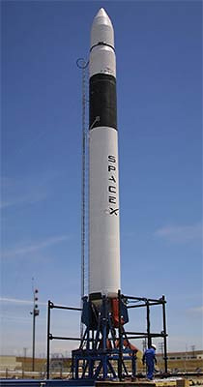

Nut van Falcon 1:

The Falcon 1 was SpaceX's first orbital rocket, and it was in use until 2009 when it was retired after several flights. While it had a short operational life, it played a significant role in SpaceX's early development and in advancing the commercial space launch industry. Here are the primary uses and missions of the Falcon 1:

1. **Demonstration and Development:** The Falcon 1 served as a platform for demonstrating SpaceX's engineering and launch capabilities. It allowed SpaceX to gain experience in building and launching rockets, paving the way for the more advanced Falcon 9 and Falcon Heavy rockets.

2. **Payload Deployment:** Falcon 1 was used for launching small payloads into orbit. It was capable of carrying payloads weighing up to about 165 kilograms (364 pounds) to low Earth orbit (LEO).

3. **NASA and Commercial Satellites:** Some of the Falcon 1's missions included launching CubeSats and small experimental satellites for NASA and other customers. These payloads were used for various scientific and research purposes.

4. **Malaysia's RazakSAT:** One of the notable missions of the Falcon 1 was the launch of Malaysia's RazakSAT satellite in 2009. This was a remote sensing satellite used for Earth observation.

5. **Orbcomm-1 and Trailblazer:** The Orbcomm-1 and Trailblazer missions in 2008 were part of SpaceX's early commercial ventures, which aimed to provide satellite communication services and deploy a space-based internet system.

6. **Pathfinder Missions:** Some of the early Falcon 1 missions were essentially "pathfinder" missions, where SpaceX was testing the rocket's capabilities and working out any technical issues before moving on to the more powerful and capable Falcon 9.

7. **Educational and Research Payloads:** The Falcon 1 occasionally carried educational and research payloads, providing opportunities for universities and research institutions to access space.

It's important to note that the Falcon 1 was a relatively small rocket compared to the Falcon 9, and it was mainly used for smaller payloads and experimental missions. Although the Falcon 1 was retired after a limited number of flights, it represented a crucial step in SpaceX's journey to develop reliable and cost-effective orbital launch vehicles, ultimately leading to the Falcon 9 and other advanced rockets.

Falcon 9:
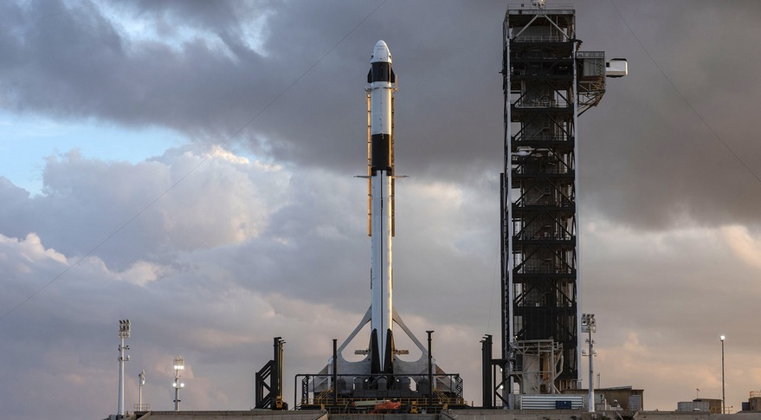

Nut van Falcon 9:

The Falcon 9 rocket, developed by SpaceX, is used for a wide range of missions and applications in the space industry. Its versatility, reliability, and cost-effectiveness make it a popular choice for various purposes. Here are some of the primary uses of the Falcon 9:

1. **Commercial Satellite Deployment:** Falcon 9 is frequently used to launch commercial satellites into various orbits, including low Earth orbit (LEO), geostationary transfer orbit (GTO), and polar orbit. It has become a go-to option for satellite operators looking to send payloads into space.

2. **Resupply Missions to the International Space Station (ISS):** SpaceX's Falcon 9, with its Dragon spacecraft, is utilized for cargo resupply missions to the ISS under NASA's Commercial Resupply Services (CRS) program. It transports supplies, experiments, and equipment to the station.

3. **Crewed Spaceflights:** Falcon 9 is used to launch the Crew Dragon spacecraft on crewed missions to the ISS, supporting NASA's Commercial Crew Program. This represents a significant step in the commercialization of human spaceflight.

4. **Space Science Missions:** The Falcon 9 has been used for launching space science missions, including telescopes, observatories, and interplanetary probes. For example, it launched the Transiting Exoplanet Survey Satellite (TESS) and the James Webb Space Telescope.

5. **Earth Observation and Remote Sensing:** Falcon 9 can be employed to deploy Earth observation satellites for purposes such as weather forecasting, environmental monitoring, and disaster management.

6. **Global Internet Connectivity:** SpaceX is deploying its Starlink satellite constellation using Falcon 9 rockets. This mega-constellation aims to provide global internet coverage, especially in underserved and remote areas.

7. **National Security and Military Payloads:** The U.S. Department of Defense and national security agencies have used Falcon 9 for launching classified payloads and military satellites.

8. **Space Exploration:** Falcon 9 can support missions beyond Earth, such as sending spacecraft to explore other planets or conduct scientific research in space.

9. **Small Payloads:** Through its rideshare program, SpaceX offers cost-effective launch opportunities for smaller payloads, enabling universities, research institutions, and startups to access space.

10. **Human Lunar Missions:** SpaceX's Starship, in development, is intended to be used for lunar missions. While the Falcon 9 may not be the primary launch vehicle for these missions, it plays a role in the overall architecture of lunar exploration.

The Falcon 9's reusability and cost-efficiency have revolutionized the space launch industry, making it more accessible and cost-effective for a wide range of customers, from commercial companies to government agencies. Its frequent launches and versatile capabilities have had a significant impact on the space sector, enabling a broad spectrum of missions and applications.

Starship:

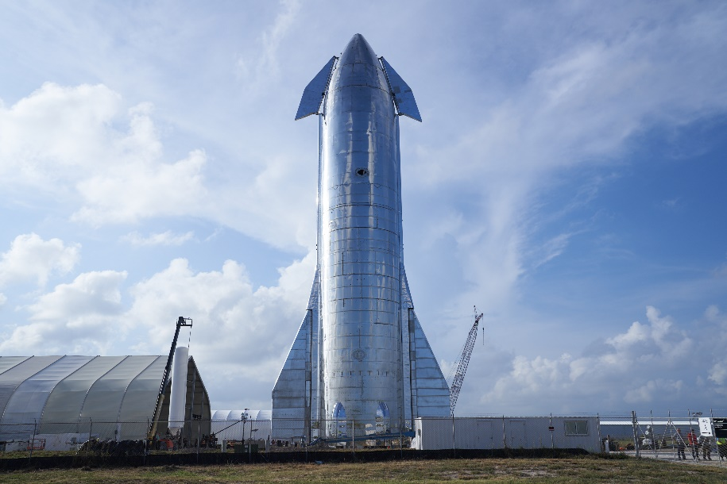

Nut van Starship:

SpaceX's Starship is a fully reusable super-heavy launch system designed for a wide range of missions and applications, with the goal of revolutionizing space travel and exploration. Here are some of the intended uses and applications of SpaceX's Starship:

1. **Crewed Space Exploration:** Starship is envisioned as a spacecraft capable of carrying humans on missions beyond Earth. It is intended to play a pivotal role in SpaceX's plans for crewed missions to the Moon, Mars, and potentially other destinations in the solar system.

2. **Lunar Missions:** SpaceX has been awarded a contract by NASA to use Starship for the Artemis program, which aims to return humans to the Moon. Starship is expected to transport astronauts to lunar orbit and the lunar surface.

3. **Mars Colonization:** Elon Musk's long-term vision for Starship is to enable the colonization of Mars. The spacecraft's large payload capacity and fully reusable design are critical to this ambitious goal.

4. **Satellite Deployment:** Starship's ability to carry a significant payload capacity makes it suitable for launching large constellations of satellites, including SpaceX's own Starlink broadband internet satellites and other commercial satellite missions.

5. **Deep Space Exploration:** Starship's versatility and adaptability make it a potential choice for missions to explore asteroids, the outer planets, and even interstellar travel.

6. **Space Tourism:** Starship could facilitate space tourism by providing commercial trips to space for private individuals and paying customers, allowing civilians to experience space travel.

7. **International Space Station (ISS) Resupply:** Starship may be used for cargo resupply missions to the ISS or other future space stations, supporting scientific research and international cooperation in space.

8. **Space-Based Research:** Starship's ability to carry large payloads to various orbits can support scientific research missions, including space telescopes, observatories, and experiments.

9. **Point-to-Point Earth Travel:** SpaceX has discussed the potential use of Starship for extremely fast point-to-point Earth travel, enabling rapid intercontinental travel with suborbital hops.

10. **National Security and Defense:** Starship may have applications in national security, defense, and space-related missions, including the deployment of classified payloads.

11. **Planetary Defense:** Starship's size and capabilities could be leveraged for planetary defense missions, such as deflecting asteroids on a collision course with Earth.

It's worth noting that Starship is still in development, and its capabilities and potential applications are continually evolving. SpaceX is actively testing prototypes and refining the design to achieve its ambitious goals. The successful development and deployment of Starship would represent a significant leap forward in the capabilities of human space exploration and commercial space activities.

Geschiedenis

SpaceX, or Space Exploration Technologies Corp., was founded by Elon Musk on March 14, 2002. Since its inception, the company has rapidly evolved and made significant contributions to the space industry. Here is an overview of the history of SpaceX up to my knowledge cutoff date in September 2021:
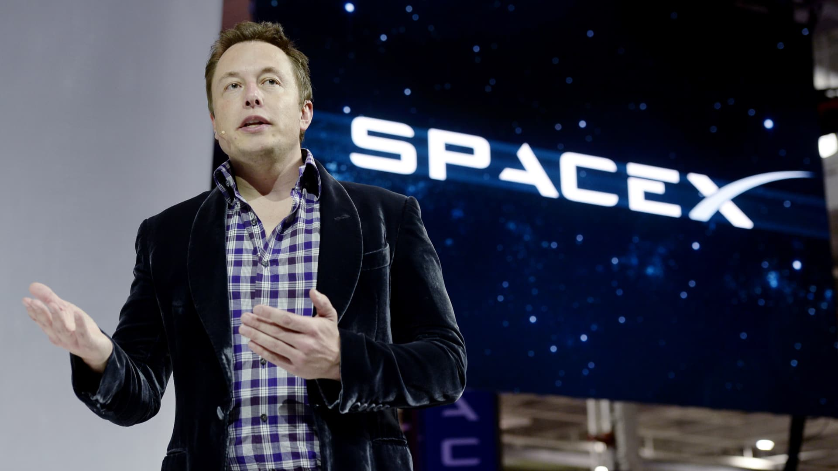

1. **Founding and Early Goals (2002-2004):** Elon Musk founded SpaceX with the primary goal of reducing the cost of space exploration and making humanity a multi-planetary species. The company initially focused on developing a small, privately-funded rocket called the Falcon 1.

2. **First Falcon 1 Launch (2006):** On March 24, 2006, SpaceX's Falcon 1 became the first privately-funded, liquid-fueled rocket to reach orbit. This marked a significant milestone in the commercial space industry.

3. **Dragon Development (2008-2010):** SpaceX began work on the Dragon spacecraft, designed for cargo and crew missions to the International Space Station (ISS). The first successful Dragon mission to the ISS took place in December 2010.

4. **Commercial Resupply Services (CRS) (2012-2020):** SpaceX signed a contract with NASA for the Commercial Resupply Services program, leading to multiple successful cargo missions to the ISS using the Dragon spacecraft. SpaceX became the first commercial company to visit the ISS.

5. **Crewed Spaceflight (2015-2020):** SpaceX's Crew Dragon spacecraft was developed to transport astronauts to the ISS. In May 2020, SpaceX successfully launched NASA astronauts Bob Behnken and Doug Hurley on the Demo-2 mission, marking the first crewed orbital launch by a private company.

6. **Falcon 9 Reusability (2015-2021):** SpaceX pioneered the concept of reusability in the space industry. It successfully landed and reused the first stage of its Falcon 9 rocket multiple times, significantly reducing launch costs.

7. **Falcon Heavy (2018):** SpaceX launched the Falcon Heavy, the most powerful operational rocket in the world. The maiden flight included the iconic launch of Elon Musk's Tesla Roadster into space.

8. **Starlink Satellite Constellation (2019-2021):** SpaceX began deploying its Starlink satellite constellation to provide global internet coverage. Hundreds of Starlink satellites were launched using Falcon 9 rockets.

9. **Artemis Lunar Program (2020):** SpaceX was selected by NASA to provide a human landing system for the Artemis program, which aims to return astronauts to the Moon. The lunar lander will be based on the Starship spacecraft.
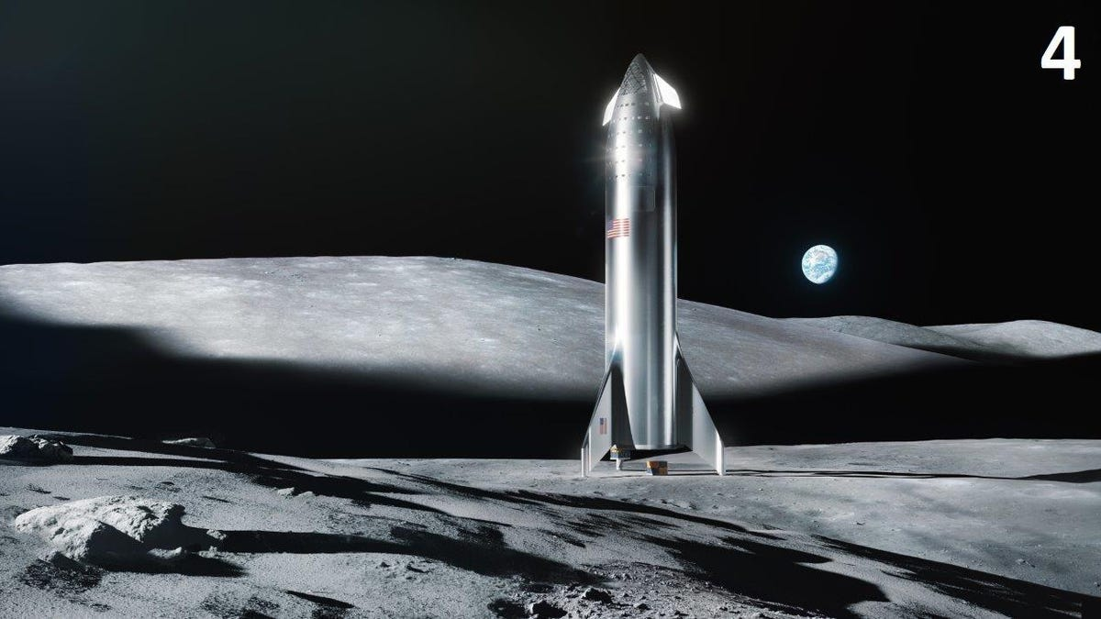

10. **Starship Development (2020-2021):** SpaceX actively developed its Starship spacecraft, intended for a wide range of missions, including missions to Mars and beyond. Multiple Starship prototypes underwent testing.

11. **Starship SN15 (2021):** Starship SN15 marked a major success for SpaceX, as it completed a high-altitude flight and a safe landing, demonstrating significant progress in Starship development.

12. **Space Tourism and Commercial Missions:** SpaceX announced plans for space tourism missions and continues to carry out numerous commercial satellite deployments and space science missions.

SpaceX has played a pivotal role in reshaping the space industry, focusing on innovation, reusability, and the goal of interplanetary colonization. Its achievements have advanced the cause of space exploration and have made significant contributions to both scientific research and commercial ventures in space. Please note that developments have continued beyond my knowledge cutoff date in September 2021.

Hieronder de concurrerende websites:

Concurrerende websites
Euro Space Center (https://www.eurospacecenter.be/nl/)
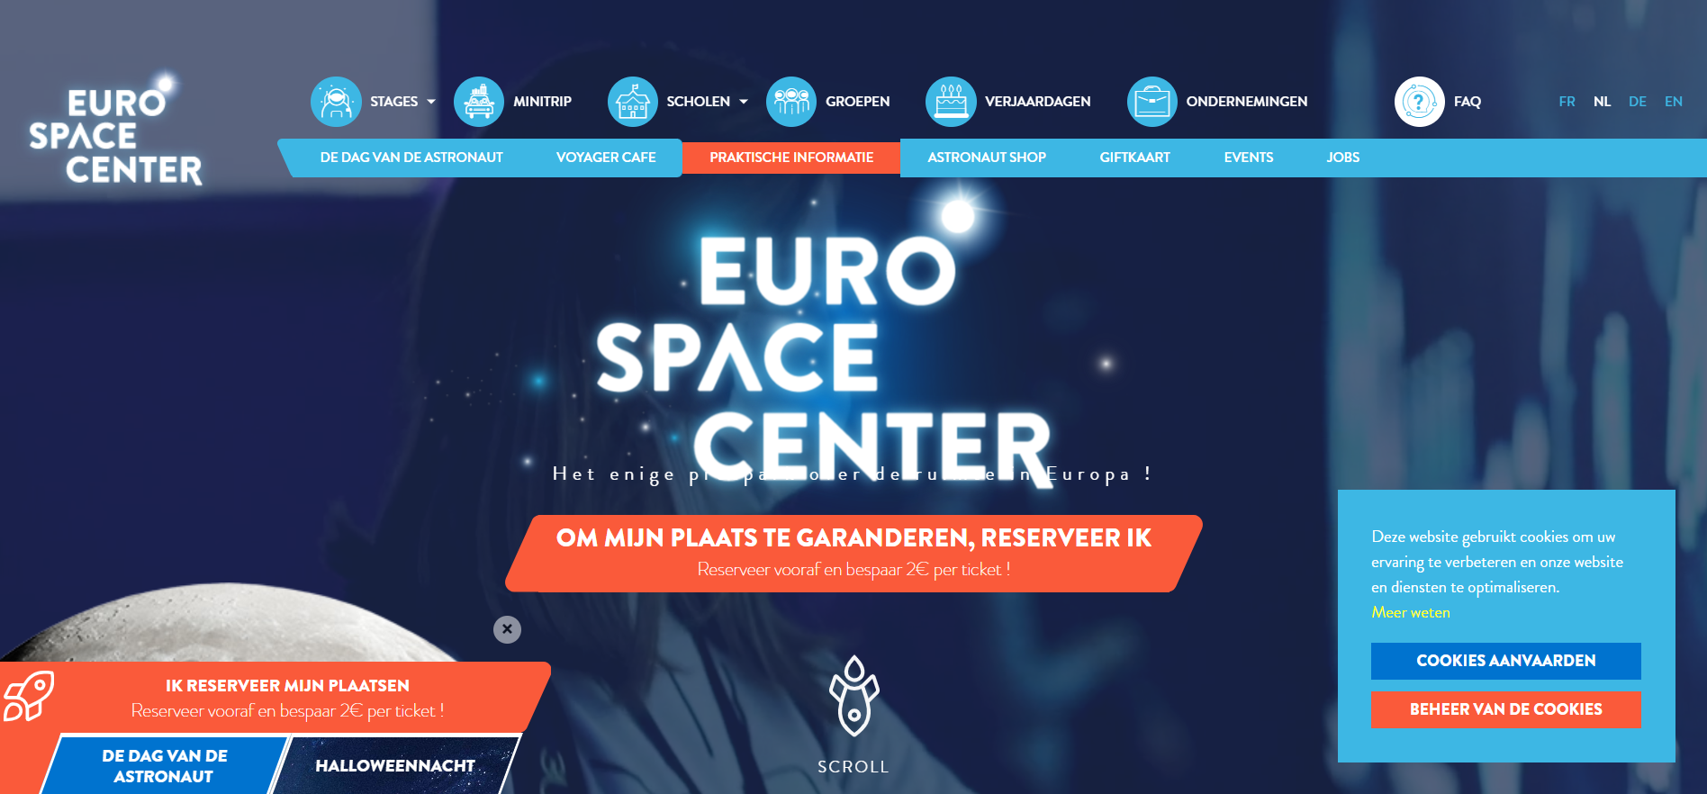
SpaceX (https://www.spacex.com/)
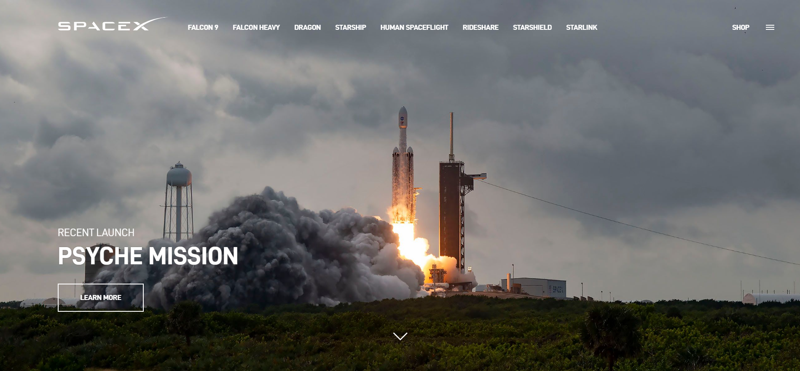
Spacepage.be (https://www.spacepage.be/nieuws/)
